EXPERIMENT 3 Date:

Install Virtual Box / VMware Workstation with Different flavours of Linux or Windows OS on top of Windows 8 or Above.

AIM: To install VirtualBox / VMware Workstation on Windows 8 or above and to install
different flavours of Linux or Windows operating systems as virtual machines.

REQUIREMENTS
- Windows 8 / 10 / 11 Operating System
- VirtualBox / VMware Workstation software
- ISO file of Ubuntu / Windows OS
- Minimum 4 GB RAM
- Virtualization enabled in BIOS

THEORY (BASIC EXPLANATION)
Virtualization is a technology that allows multiple operating systems to run on a single computer.
VirtualBox / VMware creates a virtual machine, which behaves like a real computer. The existing OS is called the Host OS, and the OS installed inside the virtual machine is called the Guest OS.

PROCEDURE:
Step 1: Run the VirtualBox setups and click the “Next” option.
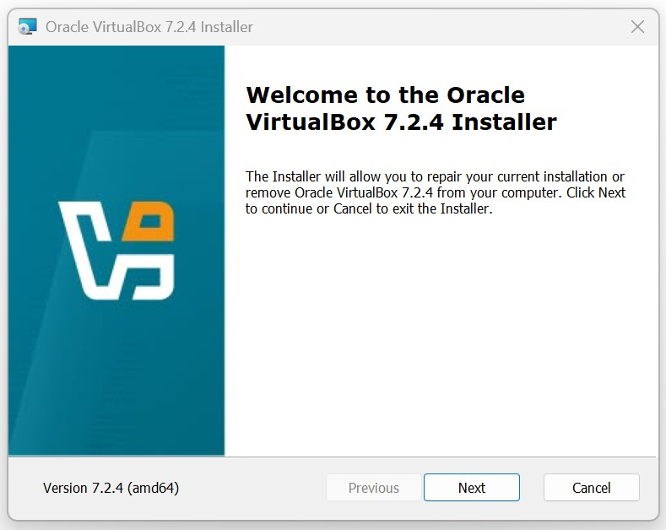

Step 2: Repeat Click on “Next” option and Finally Click the option “Install”
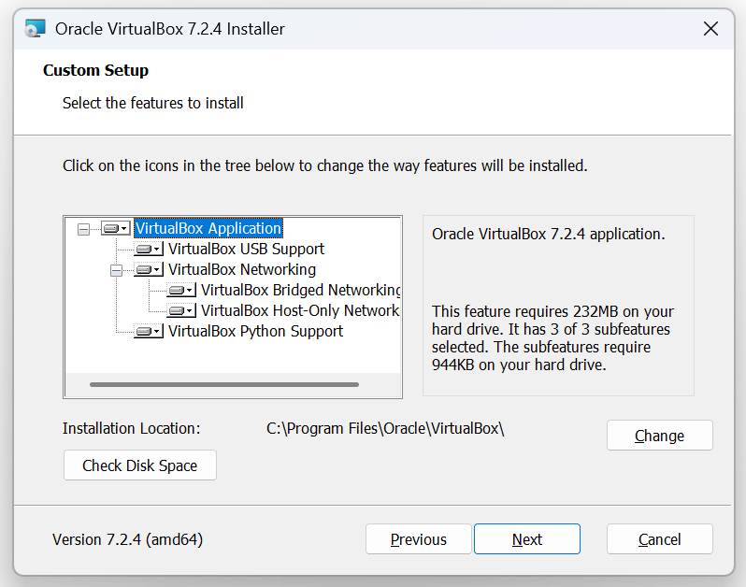
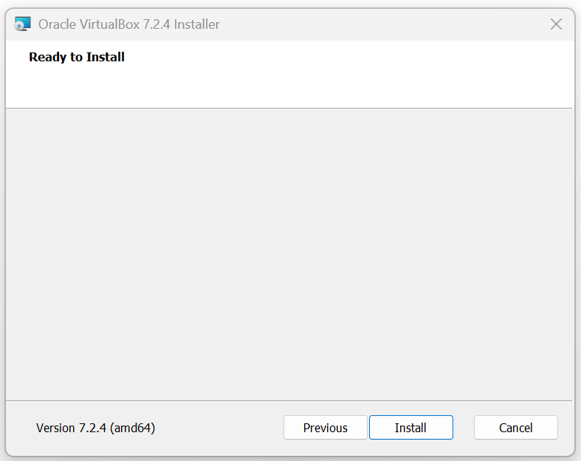
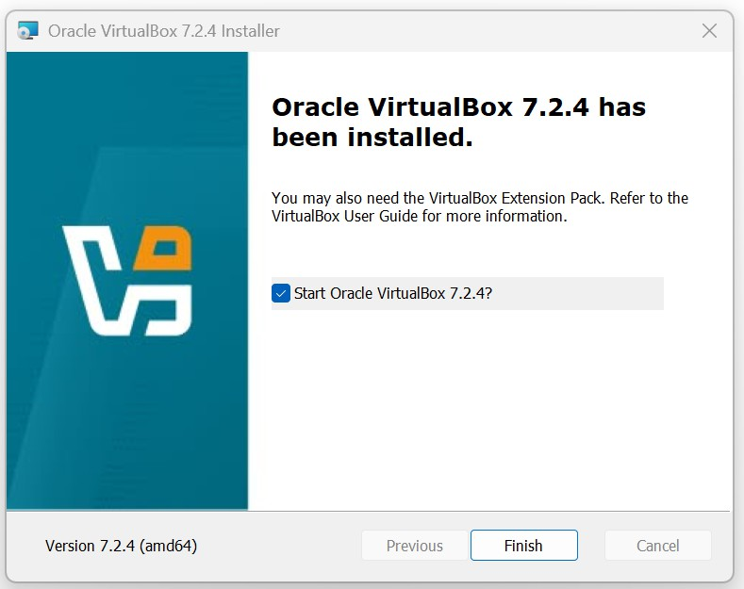

Step 3: To Install “Ubuntu” as virtual machine in “Oracle VM VirtualBox”, Open the
Oracle VM VirtualBox Manager
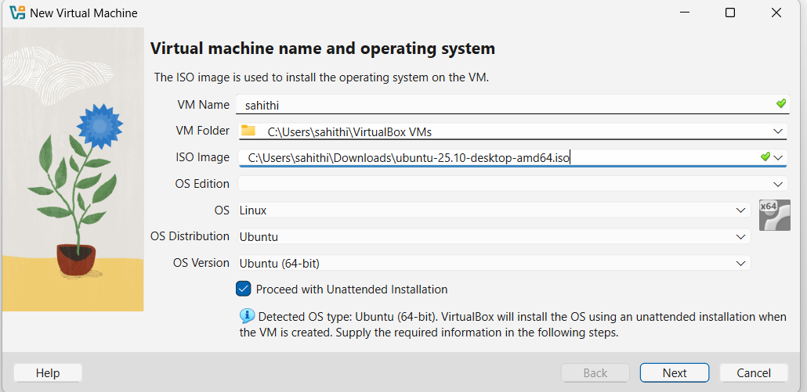
Step 4: Create new virtual machine
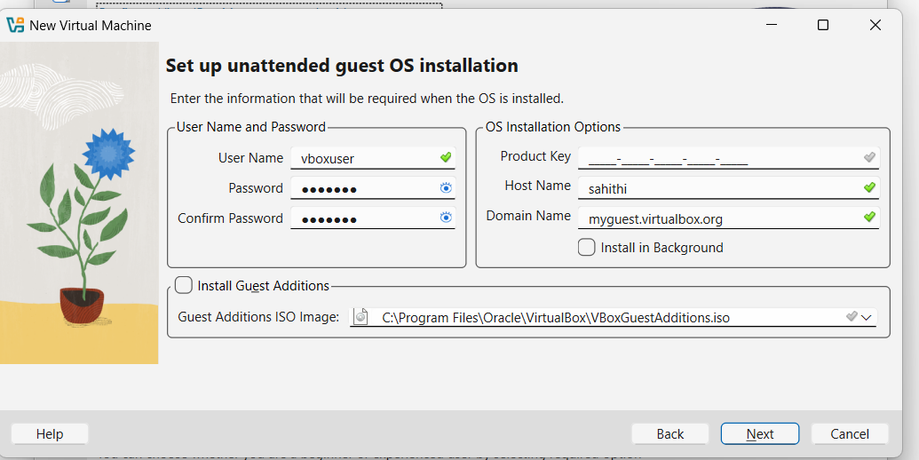
Step 5: Select the memory size

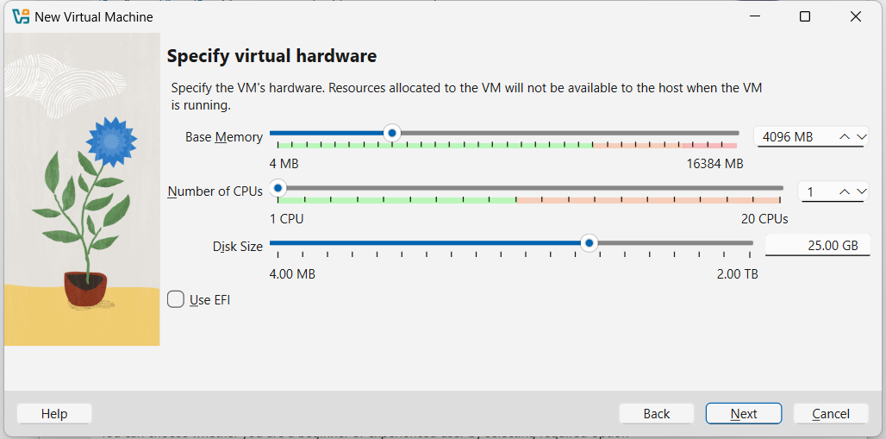

Step 6: Create a virtual hard drive
Step 7: Select the type of hardware file
Step 8: Select the type of storage on physical hard drive
Step 9: Select the size of virtual hard drive

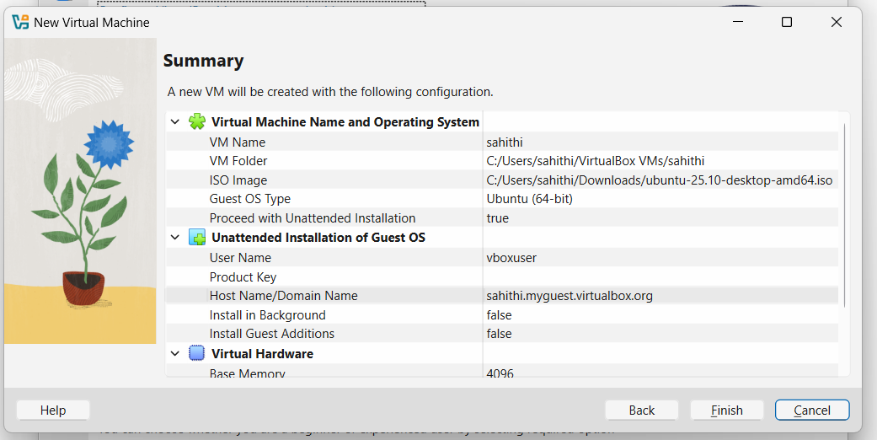

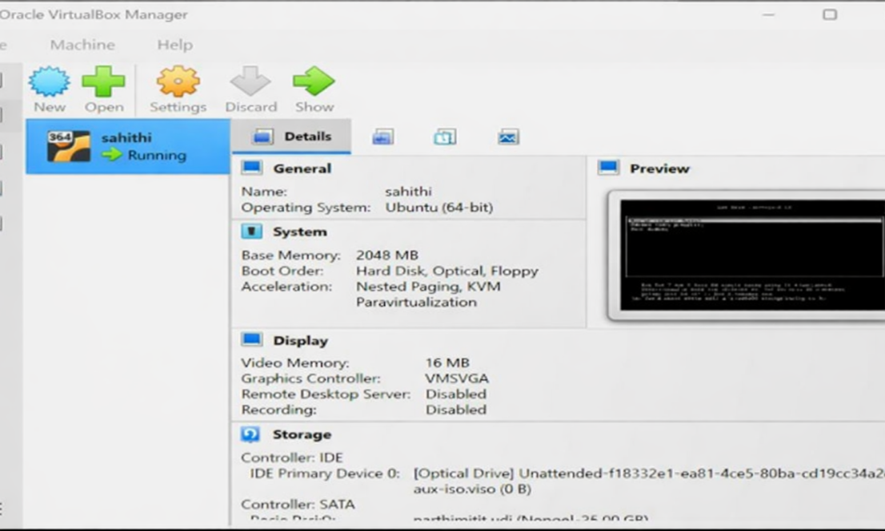

Step 10: Select the new virtual OS created and click on “Settings”

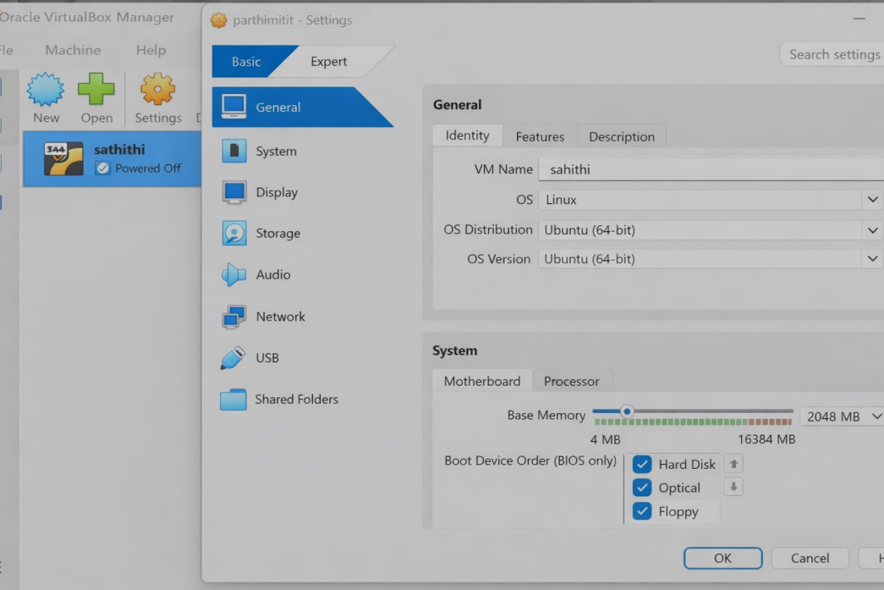

Step 11: Select “Storage” from the left panel of the window
Step 12: Click on the first icon “Add CD/DVD device” in Controller:IDE
Step 13: Select “Choose Disk” and choose the virtual machine to be used and click “Open”

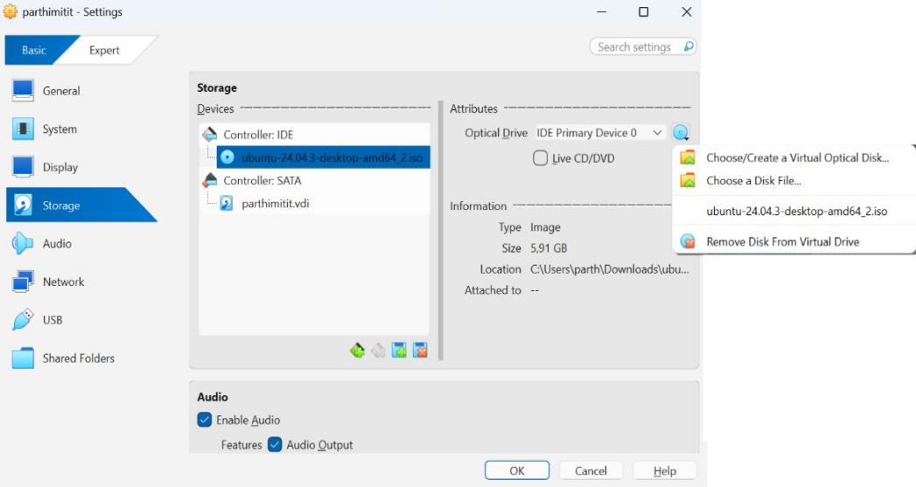
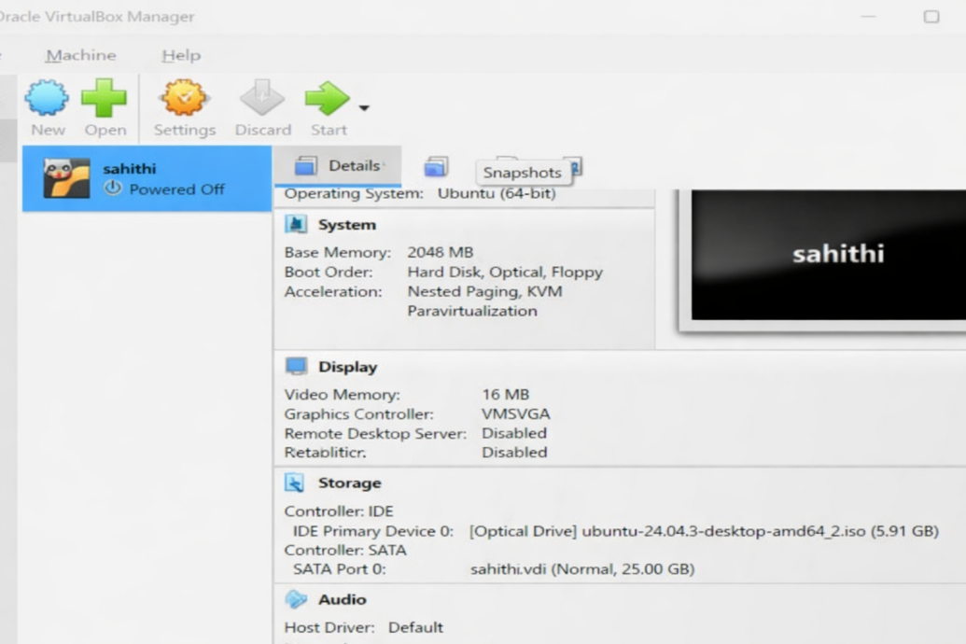

Step 14: Click “OK” and select “Start” to run the virtual machine.

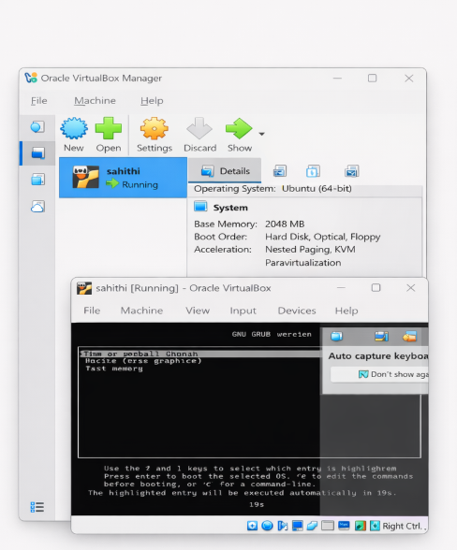

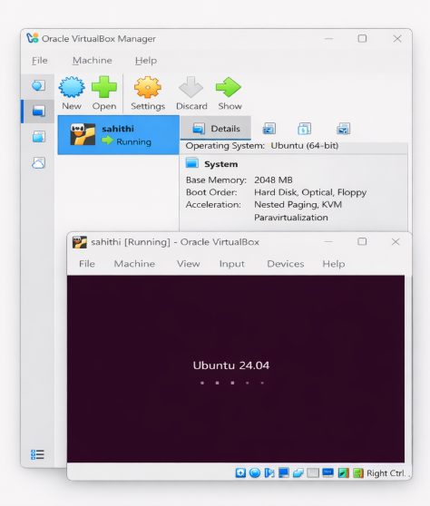
Step 15: To install ubuntu, Click 'Install Ubuntu' button

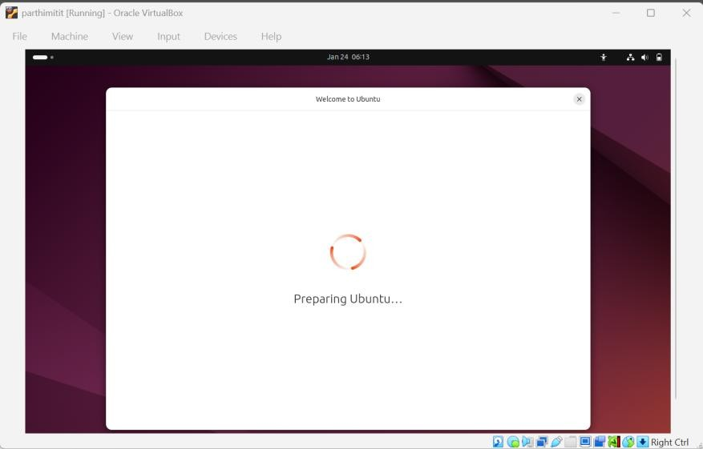
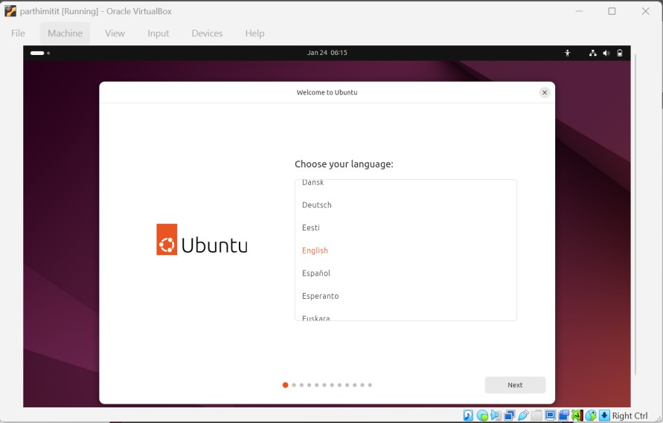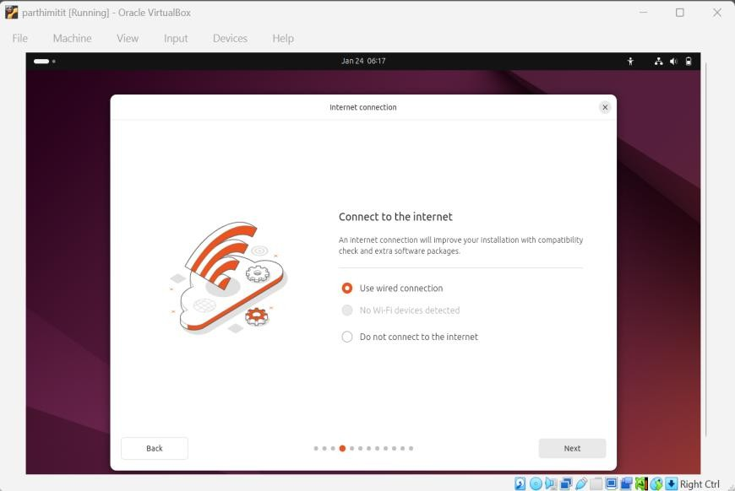
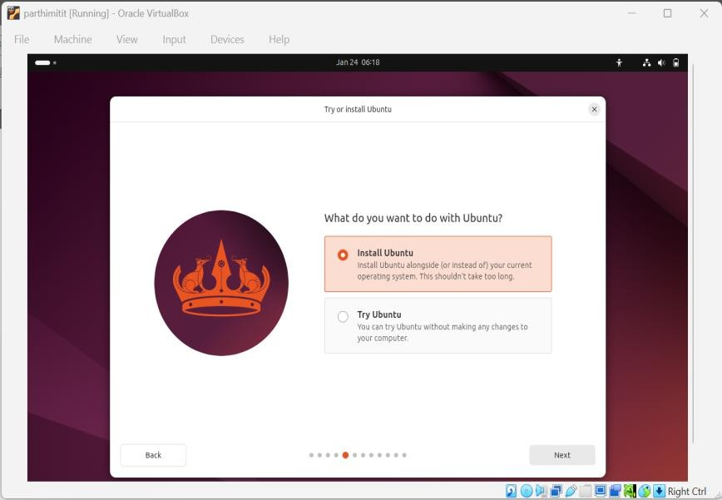
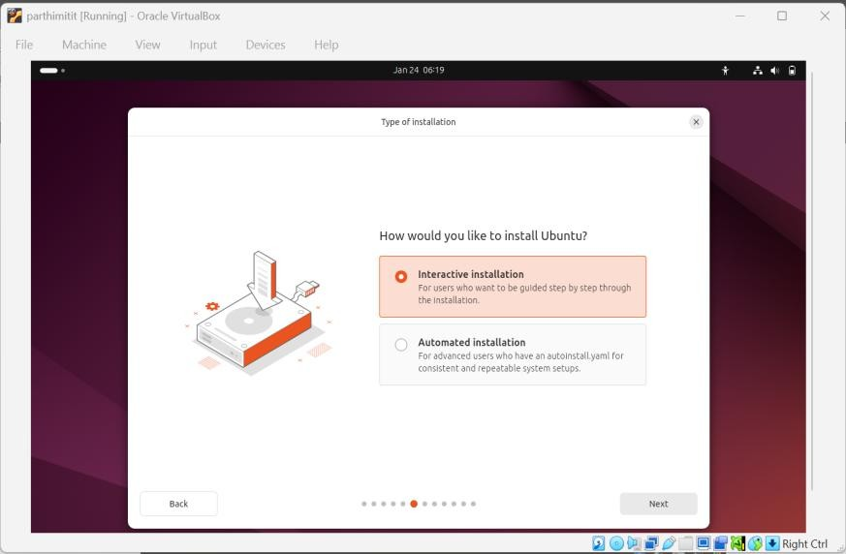

Step 16: Select 'Erase disk and install Ubuntu' option is selected and click 'Install Now' button
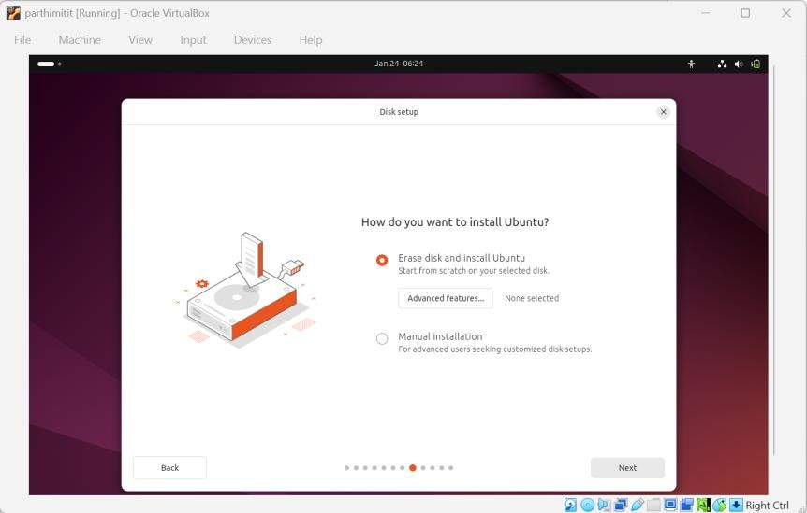
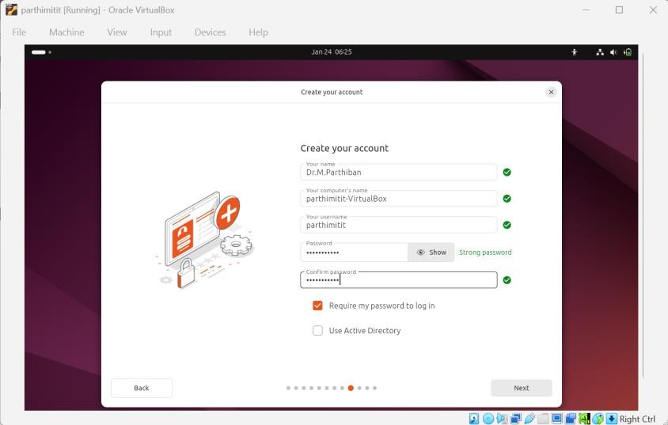
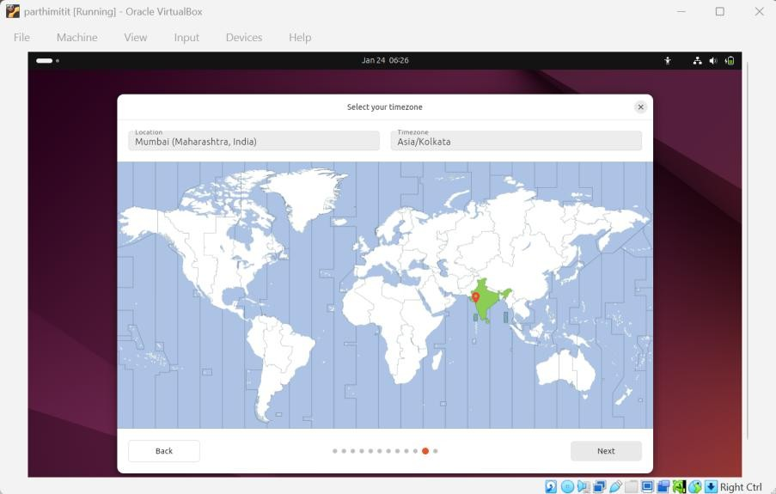
Step 17: Click 'Continue' button for upcoming dialogue box

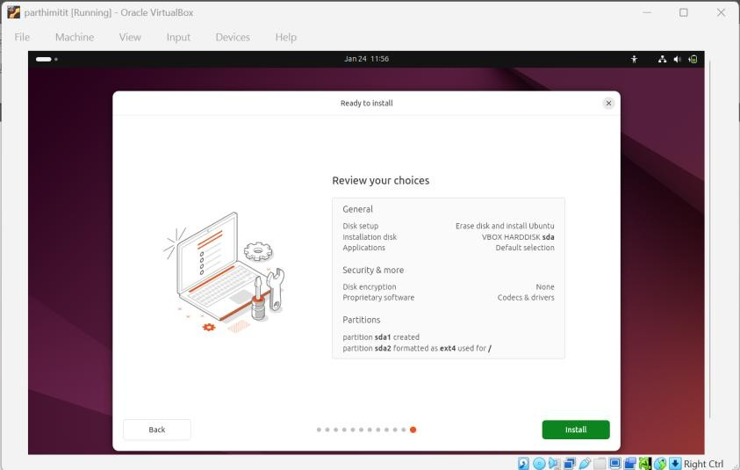
Step 18: Enter the name, username and password. Click 'Continue' button
Step 19: After completion of installation process, click on 'Restart Now' button.

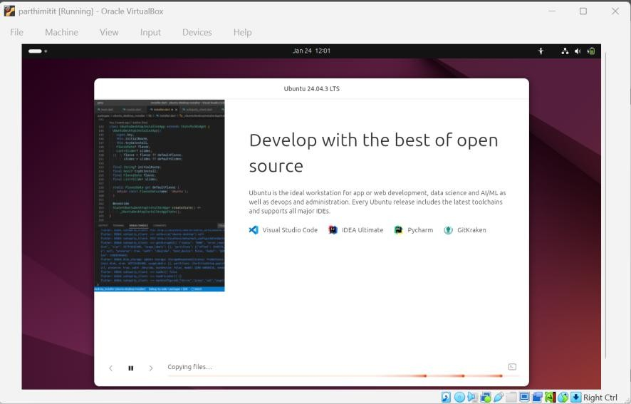
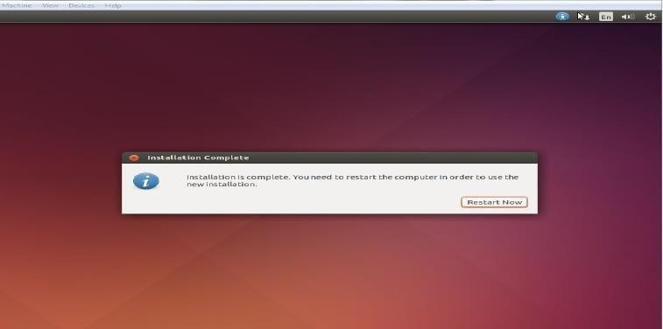
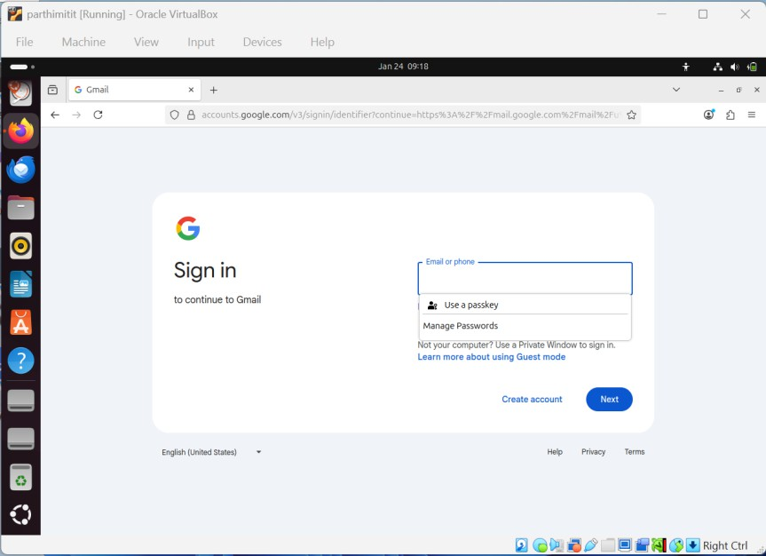

Step 20: The same way, we can install windows OS

OUTPUT:
- Ubuntu Operating System in Virtual Machine

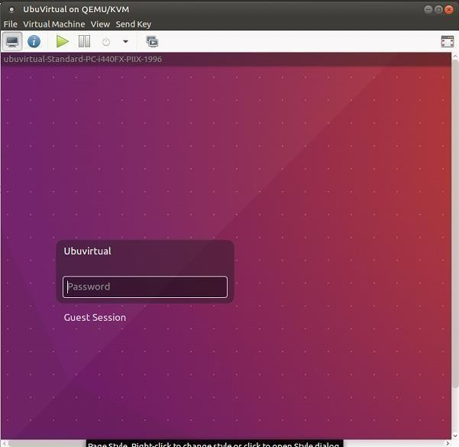
- Windows7 Operating System in Virtual Machine
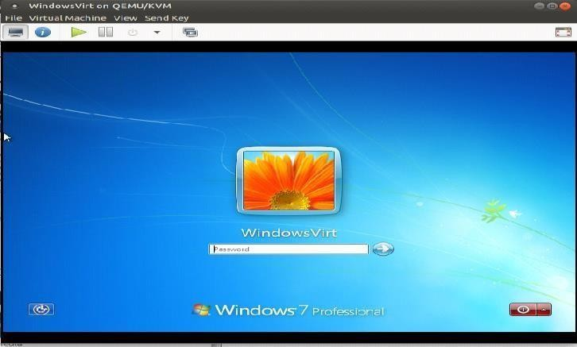

TROUBLESHOOTING / IMPORTANT NOTES
  - Enable VT-x / AMD-V in BIOS if 64-bit OS is not shown
  - “Erase disk” affects only the virtual hard disk, not Windows
  - Install Guest Additions / VMware Tools for better performance

VIVA QUESTIONS
- What is VirtualBox?
VirtualBox is a virtualization software used to run multiple operating systems on one computer.
- What is Virtualization?
Virtualization is a technology that allows multiple operating systems to run on a single physical system.
- What is a Virtual Machine (VM)?
A virtual machine is a software-based computer that runs inside a host system.

- What is Host OS and Guest OS?
Host OS is the main operating system (Windows), and Guest OS is the OS installed inside the virtual machine (Ubuntu).

- What is an ISO file?
An ISO file is a disk image used to install an operating system.

- What is VDI?
VDI is the virtual hard disk format used by VirtualBox.
- What does “Erase disk and install Ubuntu” mean in VirtualBox?
It erases only the virtual hard disk and does not affect the host Windows OS.

- Why does a 64-bit OS not appear in VirtualBox?
Because virtualization is disabled in BIOS or hardware does not support it.

- What are Guest Additions?
Guest Additions are drivers that improve display, mouse, and performance of the virtual machine.

- What is the main advantage of VirtualBox?
It allows running multiple operating systems on one computer without affecting the host OS.

RESULT:
Thus, VirtualBox / VMware Workstation was installed successfully and different flavours of Linux and Windows operating systems were installed and executed on Windows 8 or above using virtualization technology.

